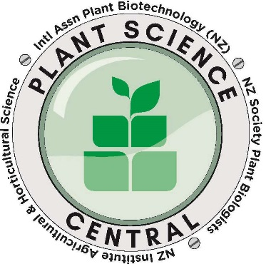

PLANT SCIENCE CENTRAL CONFERENCE
Massey University, Palmerston North
6-8 July 2021

The New Zealand Horticultural Science Advancement Trust has provided five awards of up to $300 each for students to assist attendance at the Plant Science Central Conference. To be eligible for this award you need to give a presentation at the conference

APPLICATION FORM
Closing date 24 May 2021

1. Surname:

First names:

Preferred mode of address (Mr, Mrs, Ms, etc)

2. Address for correspondence:

3. Mobile Phone:

4. Email address:

6. Brief Statement of why attendance at PSC 2021 will benefit you

7. Abstract Title:

8. Name and contact details of Supervisor who can, if necessary, provide confidential testimonials.

Signature of candidate:.............................. Date:.......................

Email application to:
Jenny Taylor, Conference Secretary
secretariat@agscience.org.nz

