Plant Science Central Conference  “Plants for a Brighter Future”  Massey University, 2 – 4 July 2019  Please lay out your abstract using the template below. | 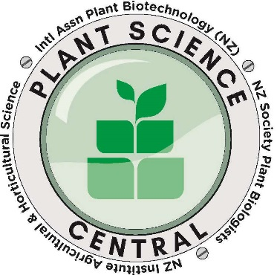
Please do not change the font in size or style.

Please indicate: ☐ Oral Presentation ☐ Poster

Abstract Template

Add TITLE here in bold

Authors: surname, initials; presenting author underlined.
Lead author¹, Other Authors^{2,} Other Authors³

Addresses: use superscripts if more than one address; and use a separate line for each address.
¹ Employer, location and country of lead author
² Employer, location and country of co-author

Email: Click here to enter email

Key Words: Click here to enter text.

Abstract
Up to 250 word abstract, full justification. One paragraph only, no references.
Click here to add ABSTRACT text.
(Example of Abstract layout is shown below)

Please delete grey sentences before submitting. Save as a docx with filename in this format: Author Surname, Initials PSC 2019 abstract.docx.

Then email to secretariat@agscience.org.nz

Example Abstract only (delete from final submission)

Insights into the Betalain Pathway Using Artificial and Natural Plant Models

Calcott KE^{1,2}, Gould KS², Davies KM¹, Harris NN³ and Schwinn KE¹

¹ The New Zealand Institute for Plant & Food Research, Private Bag 11 600, Palmerston North 4442, New Zealand
² Victoria University of Wellington, PO Box 600, Wellington, New Zealand
³ Commonwealth Scientific and Industrial Research Organization, Urrbrea, SA 5064, Australia

Email: kate.calcott@plantandfood.co.nz

Key Words Betalain Pigments, Anthocyanin Pigments

Betalain and anthocyanin pigments appear very similar, in terms of colour and in planta distribution, yet no plant contains both pigment types. Based on their mutual exclusivity, it is thought that betalain pigments replace anthocyanins in many Caryophyllales. While much is known about the anthocyanin pathway and its regulation, there are many biochemical, physiological and regulatory aspects of the betalain pathway that are not understood. In addition, it is unknown whether there are physiological reasons for the mutual exclusivity of these pigments. To address some of these knowledge gaps, we developed lines of the non-betalain species Arabidopsis thaliana that are capable of ectopically producing anthocyanins, betalains or both. Accumulation of pigments in these lines was studied using microscopy. Furthermore, these plants were fed transporter inhibitors or crossed with known anthocyanin transport mutants, allowing possible transport mechanisms of betalains from site of synthesis to storage in the vacuole to be examined. We also investigated stress induced betalain formation in Swiss chard (Beta vulgaris var. cicla cv. Bright lights) by comparing expression levels of betalain and anthocyanin/flavonoid biosynthetic genes using quantitative PCR. Our results and insights into the betalain pathway will be discussed.

Example Abstract only (delete from final submission)

